- Open a git bash – go to the required directory folder –

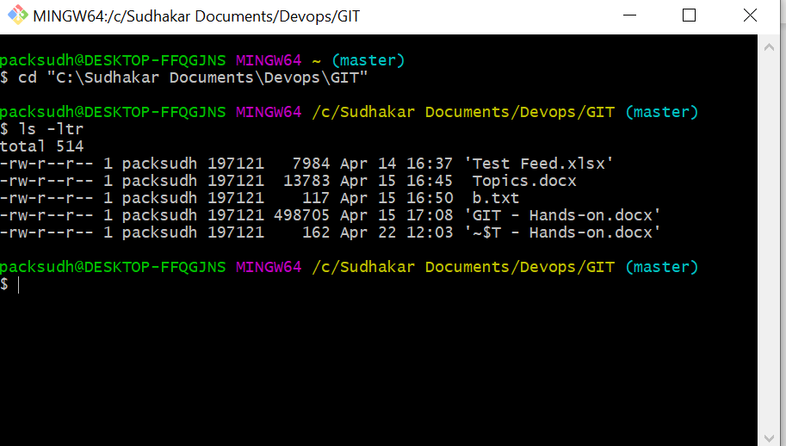

- Execute the command – git init

Below folder gets created –
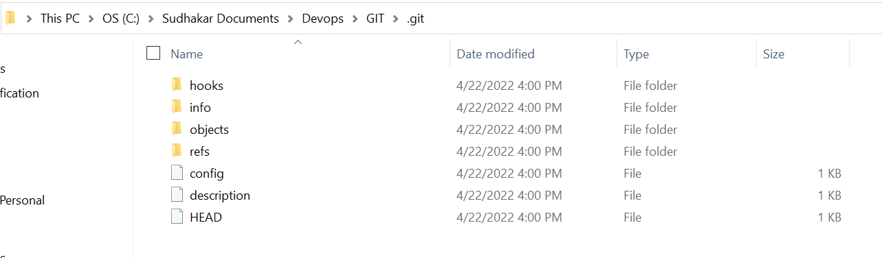

- I did create a repository by going in GIT HUB – Practice

- Execute the command - git remote add origin https://github.com/packsudh/Practice.git

- Execute the command – git add .

- Execute the command – git commit -m “First Commit”

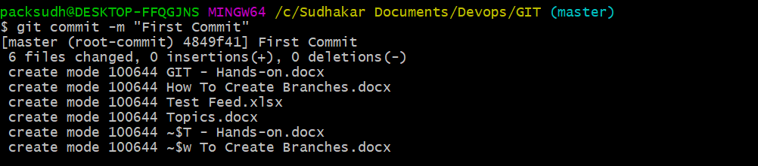

- Execute the command – git push origin master

It would ask for sign-in to your browser

Files are pushed

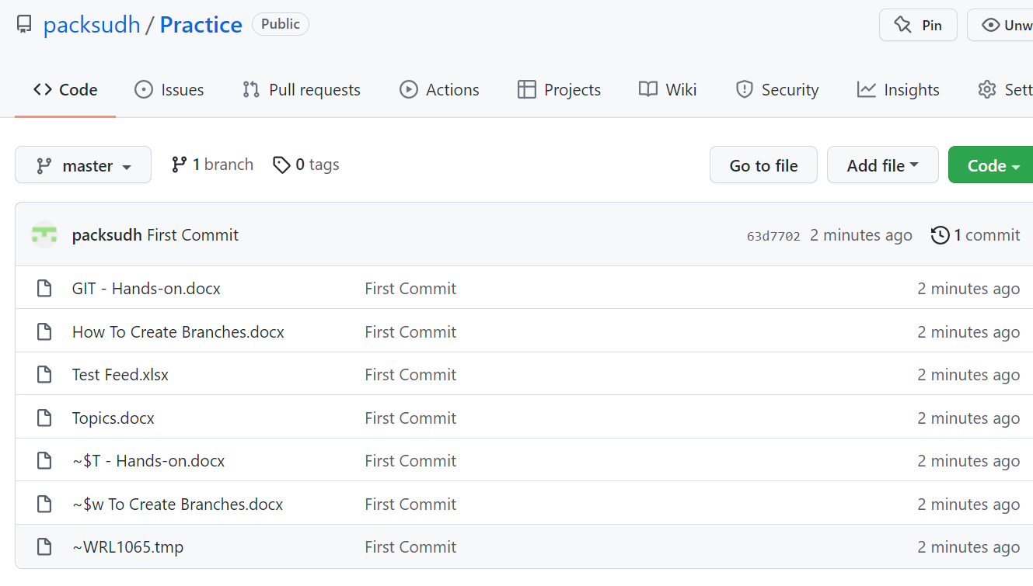

- Execute the command -> git branch development_code (Creates a new branch)

Execute the command -> git branch

Now it shows 2 branches

